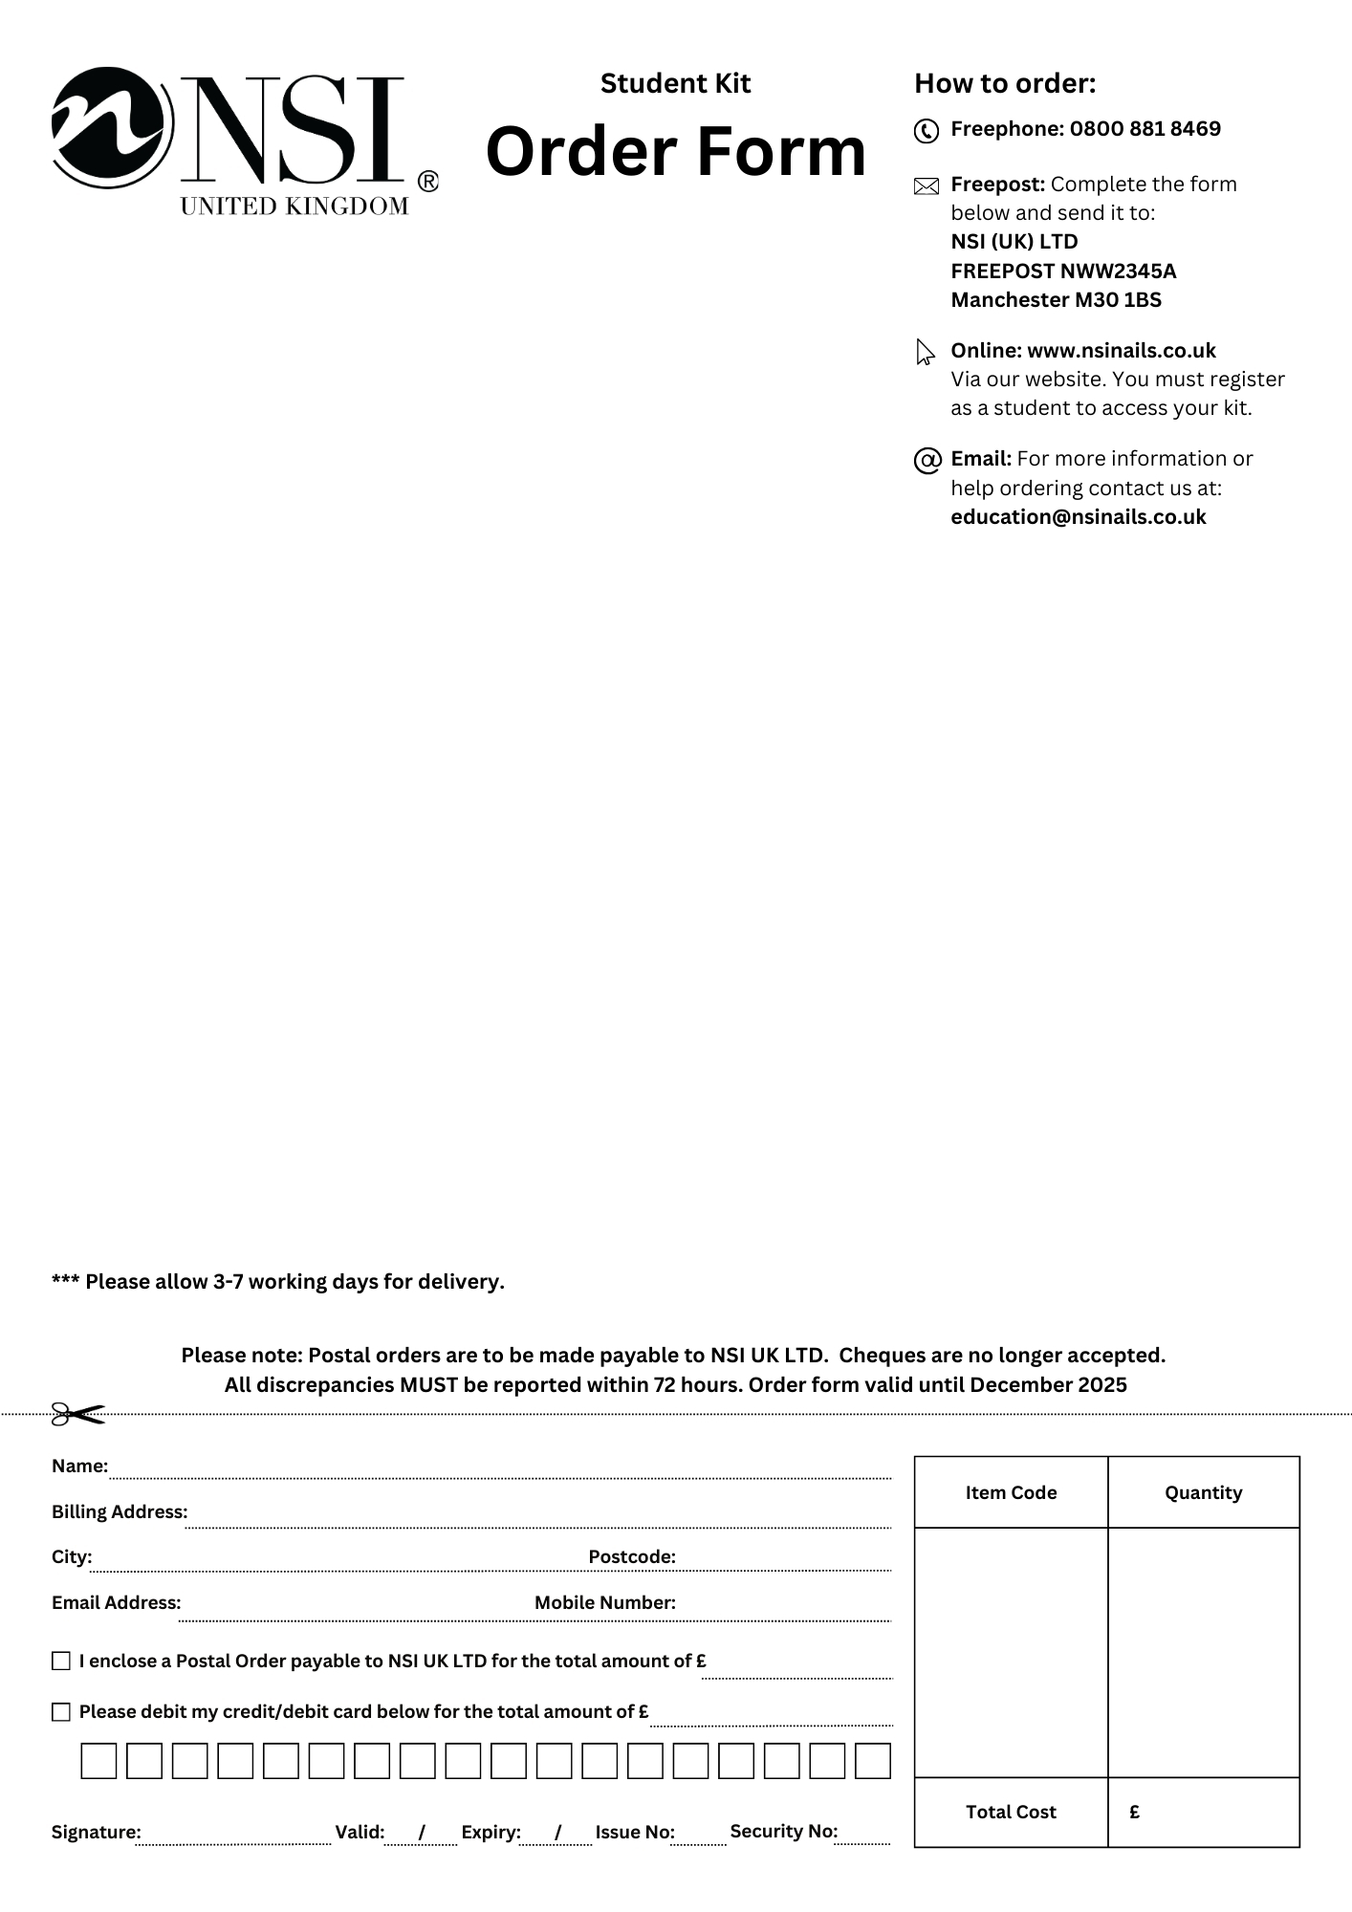­

Manicure Kit

* Nurture Oil 15ml.
* Emery Boards 120/320 Grit File x 5
* Plastic Ended Hoof Stick
* Chamois Buffer
* Round Plastic Manicure Bowl
* Economy Cuticle Nippers
* Fingernail Clippers
* Cuticle Knife
* Large Blue Vinyl Carrying Bag
* New NSI Catalogue

**Order Code** CRA011

**Price** £30.00

Craven

College