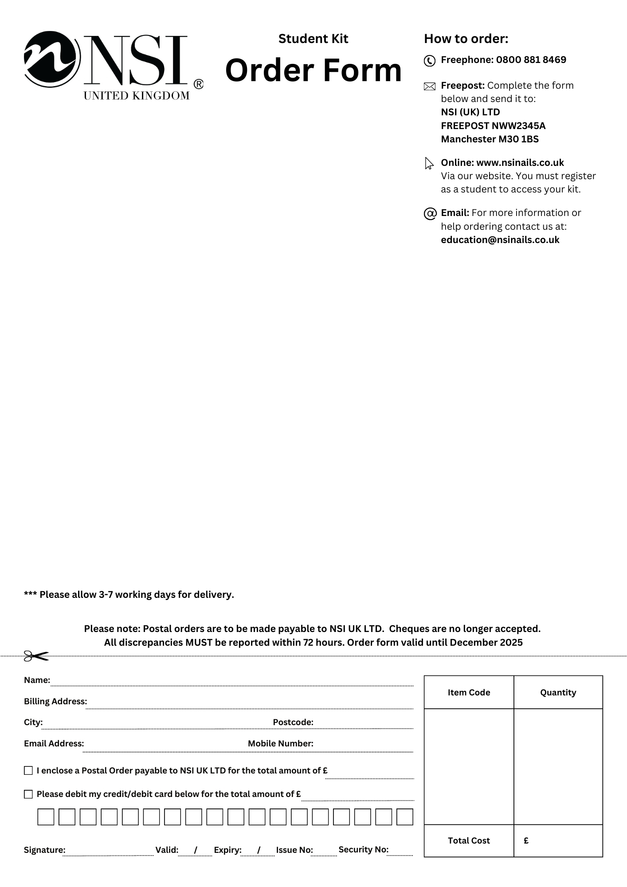­

Level 3 nails tech Kit

* Attraction Nail Liquid 4floz
* Attraction Rose Blush Powder 7gm
* Attraction Sample Kit:

Attraction Nail Liquid 2floz

Essential Bond (Acid Free) Primer 15ml

Attraction Radiant Pink Powder 7gm

Attraction Totally Clear Powder 7gm

Attraction Radiant White Powder 7gm

* No 8 Precision Brush
* No 5 Blue Compact Kolinsky Brush
* Black NSI HD 3D Compact Brush
* Dura Glue 7gm x1
* Dura 180/180 Grit File
* Dura 100/100 Grit File
* Nurture Oil 15ml
* Small Dappen Dish with Lid x2
* Large Dappen Dish with Lid x1

**Order Code** CRA006

**Price** £108.00

Craven

College

* Secrets Stiletto Forms 100ct
* Large Blue Vinyl Carrying Bag
* New NSI Catalogue