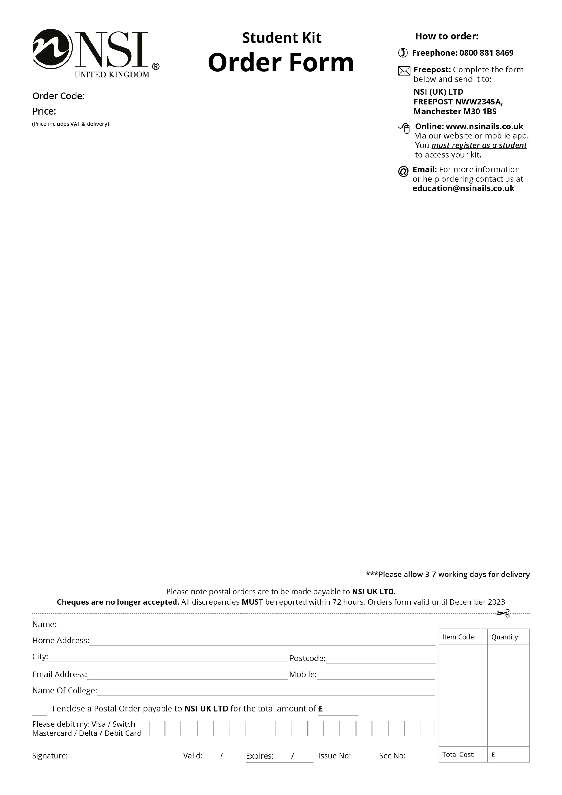­

Level 2 Full Time Kit

* Attraction Liquid & Powder Deal PPM:

Attraction Nail Liquid 8floz

Attraction Radiant White Powder 40gm

Attraction Totally Clear Powder 40gm

Attraction Purely Pink Masque Powder 40gm

* Attraction Rose Blush Powder 40gm
* Nail Pure Plus 2floz
* No 8 Precision Brush
* Nail Art Brushes 5Pk
* Dura Glue 7ml
* Essential Bond (Acid Free) Primer 15ml
* Dura File 100/100 Grit
* Dura File 180/180 Grit
* Dura Tips Natural 150ct (1-10)
* Flat Manicure Tool
* Economy Tip Cutters
* Small Dappen Dish with Lid x2
* Large Dappen Dish with Lid
* Level 2 Nails Book
* Large Blue Vinyl Carrying Bag
* New NSI Catalogue

CRA008

Craven College

£125.00