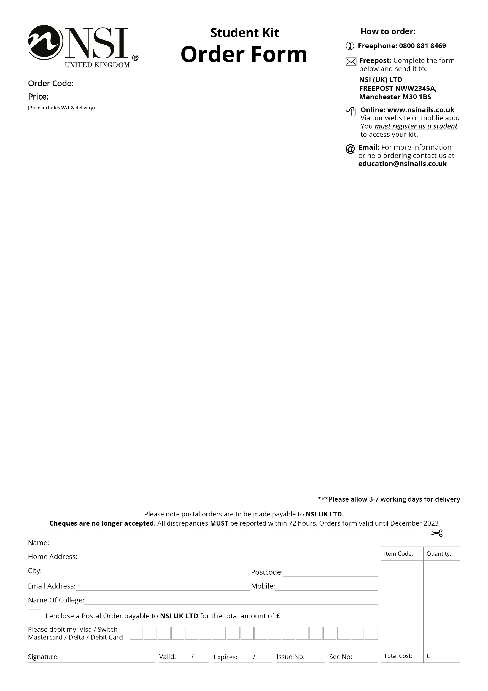­

Manicure & Pedicure Kit

* Strictly Pro Hydrating Hand Lotion 100ml
* Strictly Pro Buffing Cream 15ml
* Nurture Oil 15ml
* Emery Boards 120/320 Grit File x 5
* Grinder Foot File (Black/Gold)
* Plastic Ended Hoof Stick
* Chamois Buffer
* Round Plastic Manicure Bowl
* Economy Cuticle Nippers
* Fingernail Clippers
* Toenail Clippers
* Cuticle Knife
* Large Blue Vinyl Carrying Bag
* New NSI Catalogue

CRA001

Craven College

£36.00