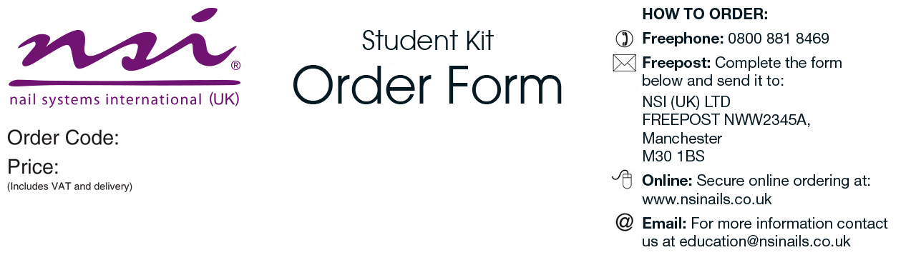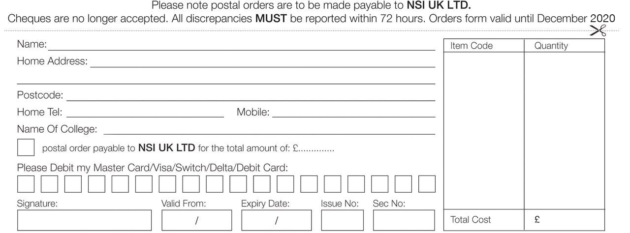

|  |  |
| --- | --- |
| Level 3 Nails Tech Kit   * Attraction Nail Liquid 4floz * Attraction Sheer Pink Powder 40gm * Attraction Rose Blush Powder 7gm * Attraction Sample Kit * Simplicité Colour Powder Start Your Engines 7gm * Simplicité Colour Powder Deep Secrets 7gm * Simplicité Colour Powder Fairy Tails 7gm * Simplicité Colour Powder Summer Melons 7gm * Simplicité Colour Powder Plum and Done 7gm * Simplicité Colour Powder Don’t Be Brass 7gm * Simplicité Colour Powder White Diamonds 7gm * Simplicité Colour Powder Bohemian Babe 7gm * Simplicité Colour Powder Free Thinker 7gm * No 8 Precision Brush * Black NSI HD 3D Compact Brush * Dura Glue 7gm x3 * Dura 180/180 Grit File * Dura 100/100 Grit File * White Block Buffer * Large 3 Way Shiner * Plastic Ended Hoof Stick * Nurture Oil 15ml * Dura Tips Natural 50ct (1-10) * Stackable Mixing Jars 5pk x2 * Shell Stone Natural * Shell Stone Red * Shell Stone Violet | * Petite Flowers Green * Petite Flowers Red * Sliced Glitter Silver * Sliced Glitter White * Red Polyester Glitter * Silver Polyester Glitter * Gold Polyester Glitter * Cracked Ice Blue * Rhinestone Wheel Round Mixed 240 * Small Dappen Dish with Lid * Porcelain Dish with Lid * Large Dappen Dish with Lid * Safety Goggles * Nail Wrap Scissors * Finger Rest * New Complete Nail Technician Book * Secrets Stiletto Forms 100ct * Large Blue Vinyl Carrying Bag * New NSI Catalogue     ***Please allow 3-7 working days for delivery    ***Please allow 3-7 working days for delivery |

Craven College

CRA006

£189.00

College

£