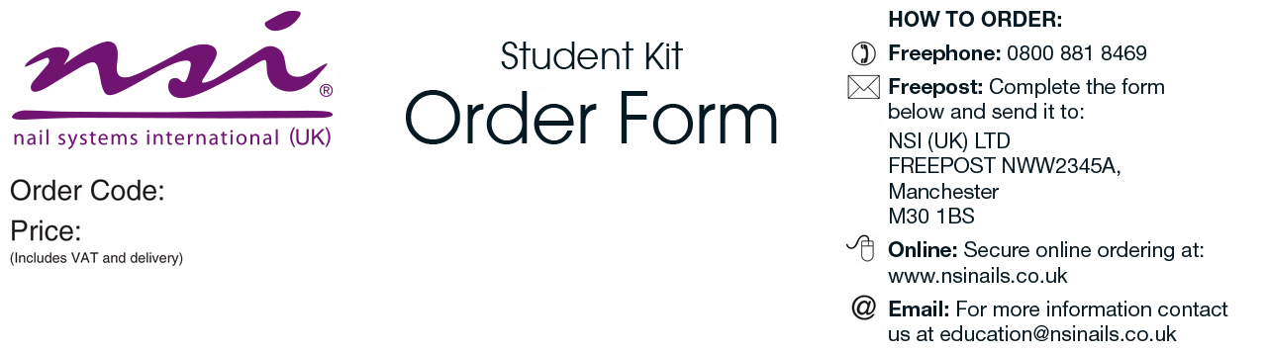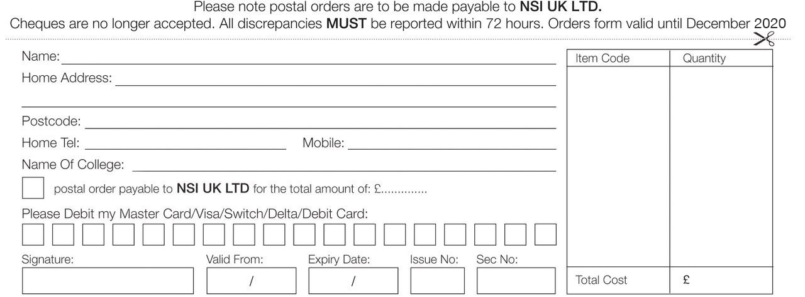

|  |  |
| --- | --- |
| Level 2 Nail Art Kit   * Nail Art Brushes 5 Pack:   Fine Liner  Super Striper  Skinny Striper  Precision Painter  Detailer   * Precious Stones Diamond Mixed Size Approx:1728 * Mixed 12 Piece Dazzling Glitter Kit * Soft Foil Silver * Silver Mirror Aluminium Nail Powder * Opal Mirror Aluminium Nail Powder * Sponge Brushes 24pk * Secrets Sparkle on the List * Secrets Sparkle Fortune Teller * Small Blue Vinyl Carrying Bag * New NSI Catalogue | ***Please allow 3-7 working days for delivery |

Craven College

CRA005

£43.00

College

£