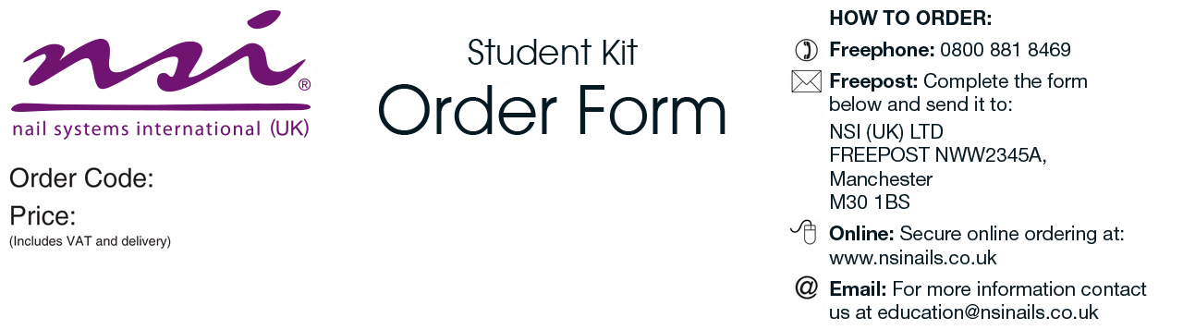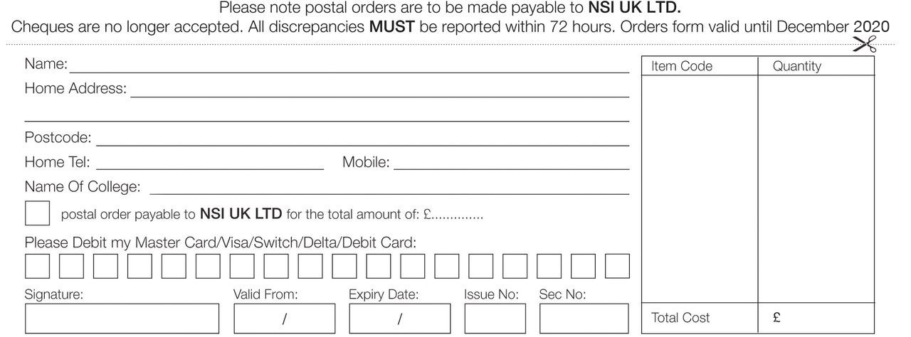

|  |  |
| --- | --- |
| Student Implement Kit   * No 8 Precision Brush * Pink Nail Technician Implement Kit:   Cuticle Pusher (Stainless Steel)  Economy Tip Cutters  Economy Cuticle Nippers  Perry Tweezers  Cuticle Scissors   * New NSI Catalogue | ***Please allow 3-7 working days for delivery |

Craven College

CRA004

£57.00

College

£