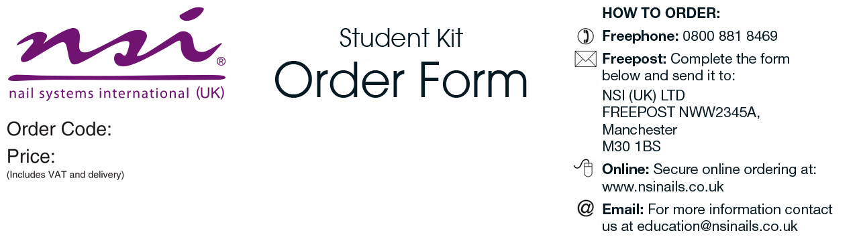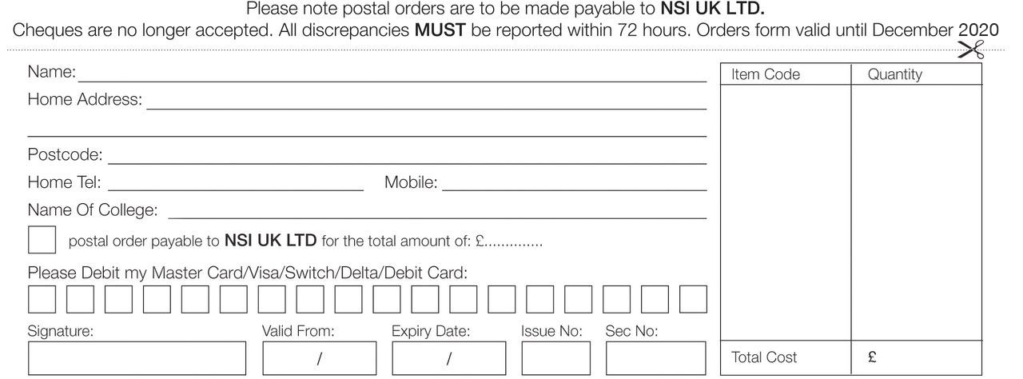

|  |  |
| --- | --- |
| Evening Nails Kit   * Purely Pink Masque - Attraction Liquid & Powder Deal   Attraction Nail Liquid 8floz  Attraction Radiant White Powder 40gm  Attraction Totally Clear Powder 40gm  Attraction Purely Pink Masque Powder 40gm   * Attraction Rose Blush Powder 40gm * Nail Pure Plus 2floz * No 8 Precision Brush * Essential Bond (Acid Free) Nail Primer 15ml * Dura Glue 7ml * Dura Tips Natural 150ct (1-10) * Flat Manicure Tool * Economy Tip Cutters * Dappen Dish with Lid * Large Blue Vinyl Carrying Bag * New NSI Catalogue | ***Please allow 3-7 working days for delivery |

Craven College

CRA003

£96.00

College

£