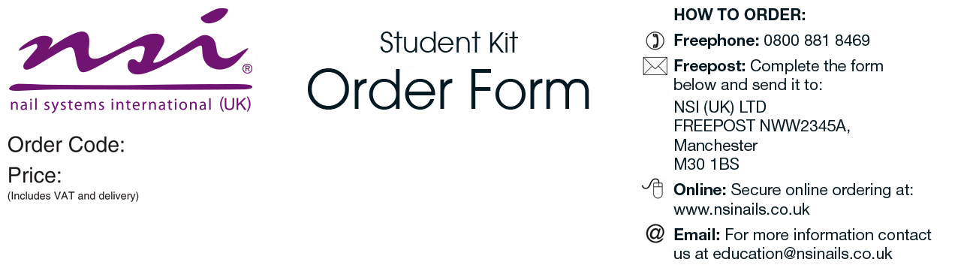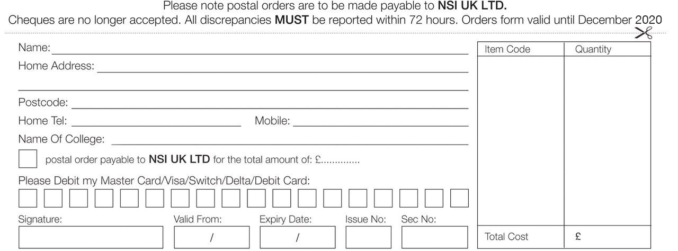

Craven College

|  |  |
| --- | --- |
| Level 3 Gel Nail Kit   * Essential Basecoat 15ml * Essential Seal 15ml * Cleanse 8floz * No 5 Blue Compact Kolinsky Brush * Secrets RG Builder Brush on White 14gm * Secrets RG Builder Cover Pink 14gm * Secrets RG Builder Clear 14gm * Tech Gel Affairs of the Heart 6gm * Tech Gel Honeymoon 6gm * Large Blue Vinyl Carrying Bag * New NSI Catalogue | ***Please allow 3-7 working days for delivery |

CRA002

£88.00

College

£