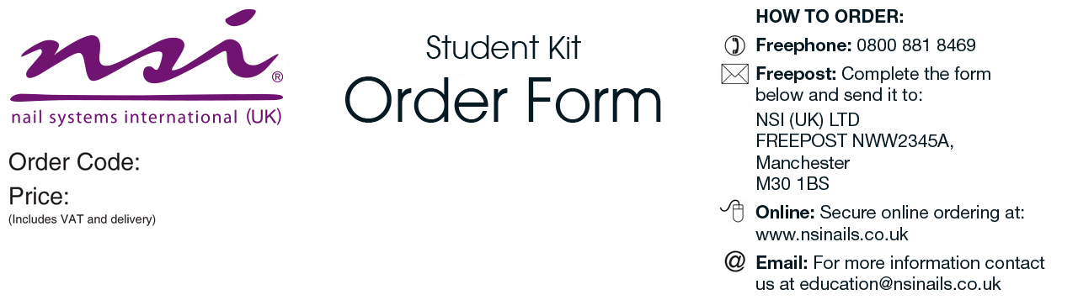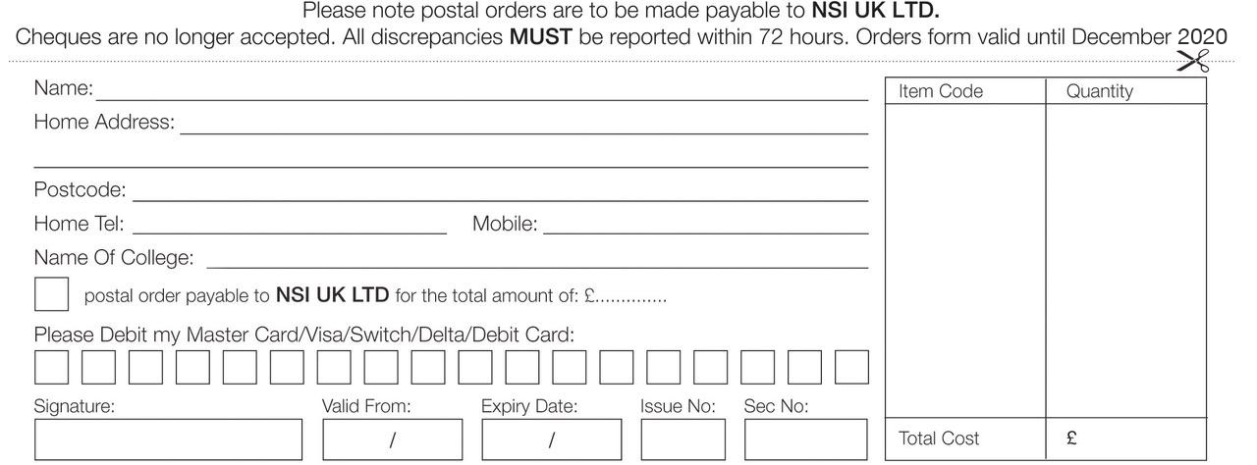

|  |  |
| --- | --- |
| Manicure & Pedicure Kit   * Strictly Pro Hand Lotion 100ml * Strictly Pro Buffing Cream 15ml * NSI Polish Pink Lemonade (French Pink) 10ml * NSI Polish Snow White (Soft French White) 10ml * NSI Polish Gossip Girl (Red)10ml * NSI Polish Basecoat 10ml * NSI Polish Gel Effect Topcoat 10ml * Non-Acetone Polish Remover 250ml * Nurture Oil 15ml * Emery Boards 120/320 Grit File x 5 * Grinder Foot File * Plastic Ended Hoof Stick * Chamois Buffer * Round Plastic Manicure Bowl * Economy Cuticle Nippers * Fingernail Clippers * Toenail Clippers * Cuticle Knife * Large Blue Vinyl Carrying Bag * New NSI Catalogue | ***Please allow 3-7 working days for delivery    ***Please allow 3-7 working days for delivery |

Craven College

CRA001

£46.00

College

£